Graphing Data: Presenting Data in Picture Form
  - INTRODUCTION:
    - A graph is data shown in the form of a picture.
      - A picture can tell you a story fast.
      - With a graph, it is not necessary to read each number to know what’s happening. The numbers form a pattern that you can recognize.
      - Graphs are popular way of making information clear.
      - They are used all over the world by all kinds of people.
  - BAR GRAPHS:
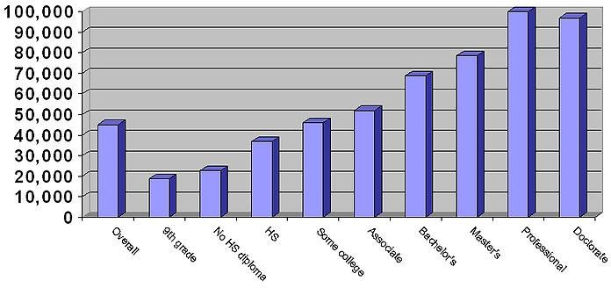
Graph 1 Dollar Income of Household by Education of the Head of the Household

    - The graph is identified by a number and a title, just like a table.
    - Each bar is labeled to show which group it represents.
    - There is a scale of values running down the side of the graph.
    - The length of the bar is compared with the scale.
      - Comparing the bar against the scale tells what the bar represents.
    - Scales are usually drawn so that equal distance represent equal amounts.
      - Always use equal amounts of space for equal changes in value.
    - Bar Graphs drawn across the page are called Horizontal Graphs.
    - Bar Graphs running up and down the page are Vertical Graphs.
    - Whether to use a horizontal or a vertical graph depends upon the size of the page, the number of bars, the lengths of the bars, the size of the labels, and the scale being used.
  - LINE GRAPHS:

Graph 2 Number of Children Born in the U.S. Annually
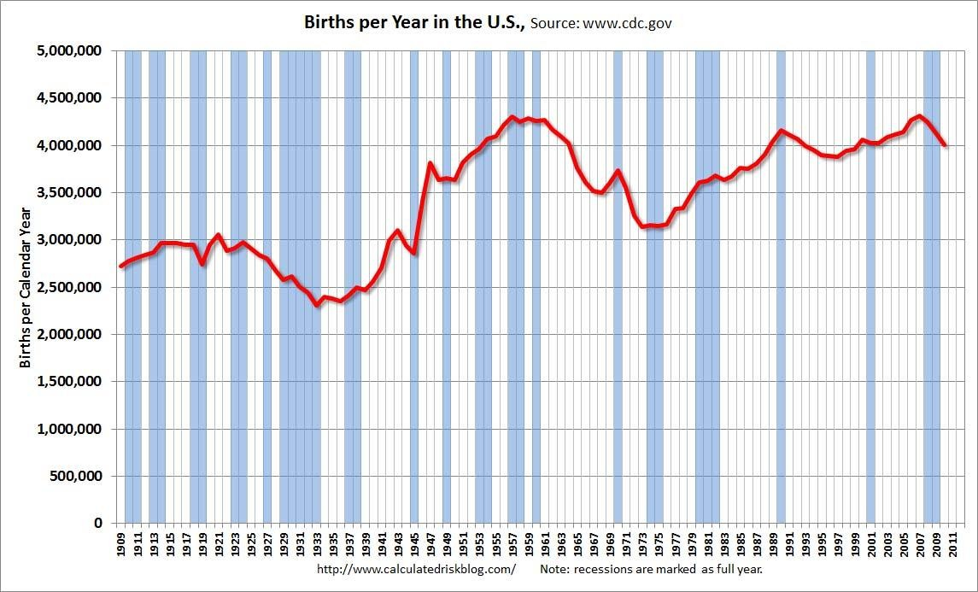

    - In a line graph, two factors are compared.
      - Statements can then be made about the relationship between the two factors.
      - The position of the line compares the two factors.
    - The line graph is useful for telling when a change is taking place.
    - The point where the line starts up of down is important.
      - It marks the beginning of the change shown by the line.
      - Conclusions can be drawn from whether the line goes up or down.
    - Like bar graphs, line graphs have numbers, titles, and accurate labeling.
      - The bottom and left sides of the graph are called it’s axes.
      - The axes are labeled to show what each side of the graph represents.
      - The axes are also marked to show the scale.
      - Equal amounts of space for equal values.
    - Graphs are usually drawn on paper ruled in squares.
      - The squares are called a grid, but the paper is called graph paper.
  - IMPORTANCE OF GRAPHS:
    - Graphs do more than present data.
      - They can help predict the future by showing trends.

      - A trend is the general direction in which a factor is moving.
      - Graphs show trends clearly.
Graph 3 The Number of People in the World
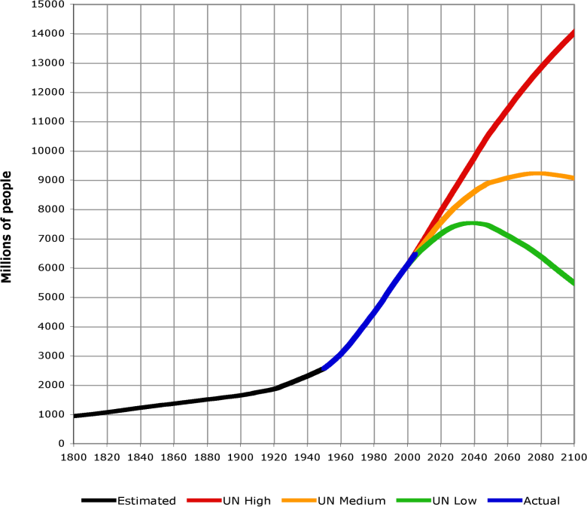
      - In Graph 3 you can really see how fast the population of the world is changing.
      - Government people can use the graph to help them determine if such things as food production and construction should be increased or decreased.
    - The data in an experiment decide whether the hypothesis is valid. Data have the highest priority.
    - Experiments are written up as research papers.
    - A scientist’s data must stand up to testing by other scientists. The same results must be seen each time an experiment is performed.
    - Scientists use graphs all the time to illustrate experimental results.
  - QUESTIONS:
    - What is a graph?
    - Why is a graph easy to read?
    - According to Graph 1, which group has the highest income?
    - How carefully did you have to read the numbers in Graph 1 to answer the first question?
    - Look at Graph 2. In what year did the birth rate start climbing after a sharp five- year drop?
    - Look at Graph 2 again. In what year did the increase in birth rate stop and the birth rate start falling again?

    - What tells you what a graph is all about?
    - If one square on a bar graph is equal to $100, how many squares longer is an $800 bar than a $500 bar?
    - How do graphs help predict the future?
    - What form of presentation seems to be the easiest way to understand data?

  - ACTIVITY:
Part-A- Drawing Bar and Line Graph (Materials: Graph Paper): Table 1 Average Monthly Rainfall in Tonka City

Month | Jan. | Feb. | Mar. | Apr. | May | June | July | Aug. | Sept. | Oct. | Nov. | Dec.
Rainfall  In cm | 4.5 | 3.5 | 7.3 | 7.0 | 9.2 | 10.2 | 6.8 | 8.0 | 8.0 | 6.5 | 5.8 | 5.0

    - Use the data in Table 1 to draw a horizontal bar graph. There are data for 12 months, so you will need 12 bars. The greatest amount of rainfall is 10.5 cm. Allow for 15 cm in your scale.
    - You will be given a sheet of graph paper. Draw a vertical line near the left edge of your paper. Leave enough space at the left of the line for labeling the bars.
    - Mark off two spaces for each bar. Leave a space between bars.
    - Write the month, in abbreviated form, to the left of each bar.
    - Use two squares to represent each centimeter of rainfall. Draw a line across the bottom of the page, one space below the lowest bar.
    - Where your vertical and horizontal lines cross, put a dot for the zero rainfall point.
    - Now put a dot on every other line across the bottom. Number the dots, starting with ) at the left and going to 15.
    - Write “Rainfall in Centimeters” across the bottom of your graph. Put the number and title at the top. Use the same title as the table because it is the same information. This is the fourth graph in this section, so make it Graph 4.
    - Measure off each bar. For January, the rainfall is 4.5 cm. You can measure off the bar in two ways. Count the squares. At 2 squares per centimeters, 4.5 cm takes 9 squares. Or, look at where the 4 cm and 5 cm lines are. You know that 4.5 cm must be halfway in-between them. Mark the end of the bar at 9 squares and darken the bar to the left end.
    - Do this for the other 11 months the same way. You will have to estimate where the divisions come for numbers like 7.3 cm. Seven is 14 squares and 7.5 is 15 squares, so you know 7.3 must be in-between.

    - Using the bar graph, what month has the highest rainfall?
    - Using the bar graph and without looking at numbers, what is the driest season in Tonka City?
    - Use the same data about rainfall to produce a line graph. First, draw axes on the graph paper you are given.
    - In line graphs, it is customary to put time across the bottom. Put a dot for each month on every other line starting where the axes cross at the left. Write the first letter of the month under each dot.
    - Write the rainfall scale up the axis on the left side. Start with 0 where the axes cross then dot every other line. Number the dots from 0 to 15.
    - Don’t forget to write “Rainfall in Centimeters” along the side. Put the number and title across the top. This is the fifth graph in this section.
    - Follow the January month line up from the bottom to where it reaches the 4.5 cm line coming across. This is 9 squares up. Put a dot there.
    - Put a dot on the February line at 3.5 cm. That is 7 squares up. Mark the rest of the month lines with a dot at the point showing their rainfalls.
    - Connect the dots with a line going from month to month in order through the year.
    - Using the line graph, which season is wetter, spring or summer?
PART-B- The Weight of a Pendulum (Materials: String, tape, paper clips, washers)
- Take a piece of string about 60 cm long. Bend a paper clip into a hook. Tie it to one end of the string.
- Tape the other end of the string to a desk or table.
- Hang a washer on the hook.
- Pull the washer sideways about 10 cm (the width of your hand).
- Draw a table in which to record data. You need space for two trials each of pendulums with one, two, three, four, and five. Do not change the length of the pendulum once you have started taking data.
- Count the number of swings for one minute. Do this twice with one washer, two washers, three washers, four washers, and five washers. Record the number of swing in your table.
- Use your table of data to produce a line graph.
- What was your hypothesis about whether more mass causes more or fewer swings per minute?
- What did the data show about the number of swings with different masses? or, Will more mass cause more swings per minute or fewer swings per minute?
- Make a statement of what mass has on how fast a pendulum swings.

